

FPT-aptech computer education

**Report eProject**

**Nextag – Wallet Shop**

***Batch:*** T2307A

***Semester:*** 1

***Course:*** ePRJ

***Group:*** 3

***Members:***

1. Nguyen Thanh Van - vanntth2307003@fpt.edu.vn

2. Bach Ngoc Anh - anhbnth2307012@fpt.edu.vn

3. Nguyen Thanh Phong - phongntth2307005@fpt.edu.vn

4. Nguyen Quoc Khanh - khanhnqth2307015@fpt.edu.vn

5. Nghiem Thai Vu - vuntth2307034@fpt.edu.vn

***Instructor:*** Nguyen Duy Hoang

**Table Of Content**

**1.** **Introduction** 3

**2.** **Problem Statement** 4

***2.1 Problem Abstraction:*** 4

***2.2 Requirement Specification:*** 4

**3.** **Site Map Of The Website** 6

**4.** **Use Case** 7

**5.** **Flow Chart** 8

**6.** **Main Screens Of The Website** 14

**7.** **Hardware/ Software Requirements** 17

***7.1*****Hardware** 17

***7.2*****Software** 17

# 

# **Introduction**

The thirst for learning, upgrading technical skills and applying the concepts in real life environment at a fast pace is what the industry demands from IT professionals today. However busy work schedules, far-flung locations, unavailability of convenient time-slots pose as major barriers when it comes to applying the concepts into realism. And hence the need to look out for alternative means of implementation in the form of laddered approach.

The above truly pose as constraints especially for our students too! With their busy schedules, it is indeed difficult for our students to keep up with the genuine and constant need for integrated application which can be seen live especially so in the field of IT education where technology can change on the spur of a moment. Well, technology does come to our rescue at such times!!

Keeping the above in mind and in tune with our constant endeavor to use

Technology in our training model, we at Aptech have thought of revolutionizing the way our students learn and implement the concepts using tools themselves by providing a live and synchronous eProject learning environment!

# **Problem Statement**

## ***2.1 Problem Abstraction:***

## NEXTAG is selling various types of Purse and Wallets. The company advertises by distributing the pamphlets, advertising on television and so on. Due to rapid development in internet field, the company decides to launch a website where people

## will get all the information about the various products available with them easily.

## ***2.2 Requirement Specification:***

The web site is to be created based on the following requirements:

1) The Home Page should be created with proper sections and with a suitable

logo.

2) Home Page should contain details on Purse and Wallets with suitable images.

3) The site should display a menu which will contain the options for brief

introduction about the various purse and wallets available, location of the

shop and any other information if required.

4) The information should be categorized according to the brand names of the

products like if a User wants to see only “LOUIS VUITTON” products or any

other companies products then he/she can click on a Link/button/menu etc

and can see only that Brand products.

5) When a user selects any particular brand, a list of products for that brand will

be displayed

6) A brief summary of features of individual products should be displayed on the

Web Page along with the product but detailed Features should be stored in

Individual Word documents which can be downloaded or viewed by the User

who wishes to see the same.

7) The user should also be able to compare the various products of different as

well as similar brands.

8) There should be a “Contact Us” page which will have the Address of the

Company which is as follows and the mail address which when clicked will

invoke the local mail client from where they can send an email.

# **Site Map**

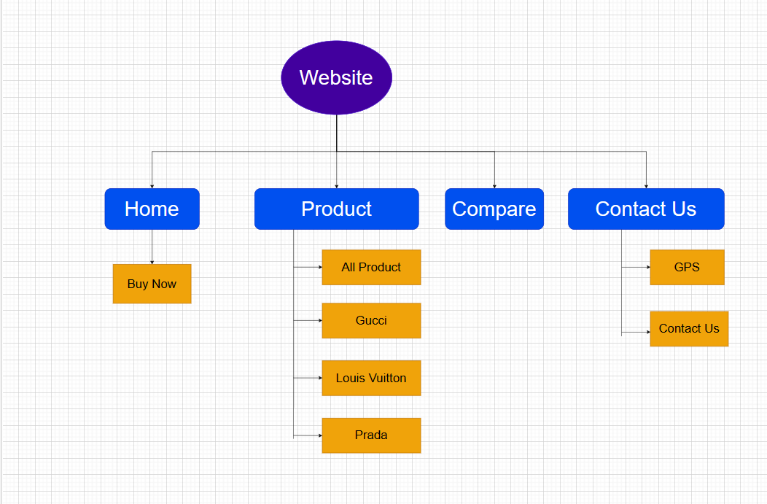

# **Use Case**

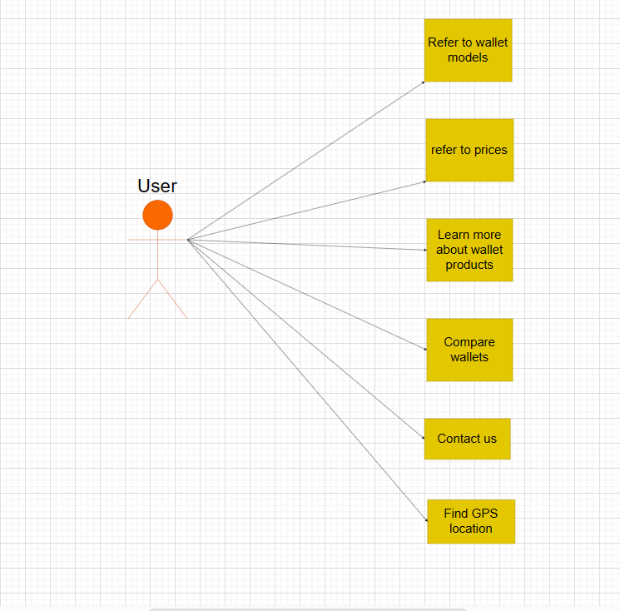

# **Flow Chart**

**1.Buy now**

# 

**2. All Product**

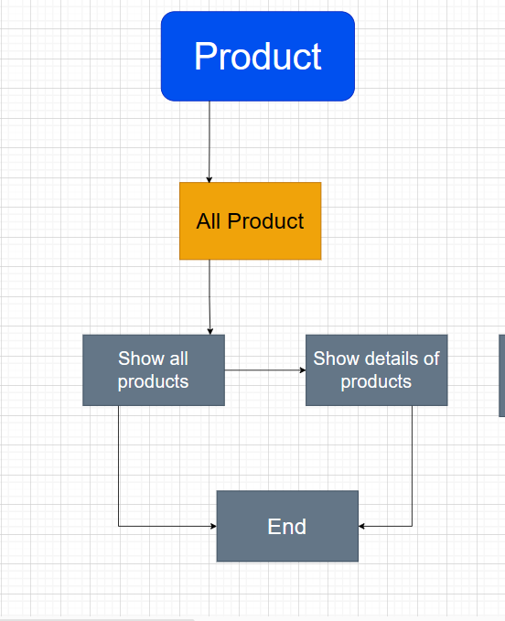

**3.Gucci**

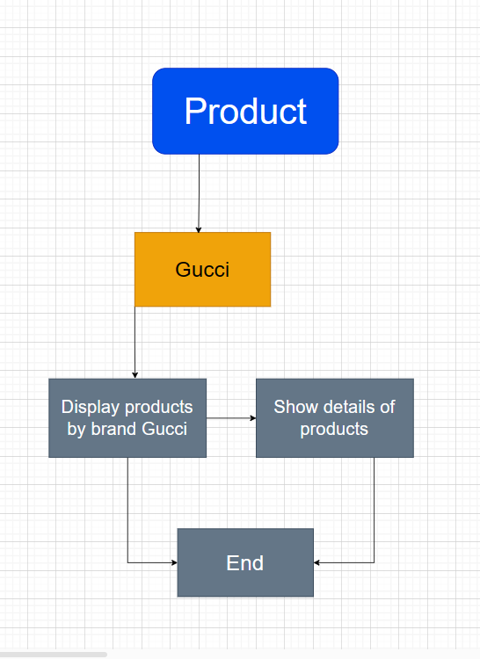

**4.Louis Vuitton**

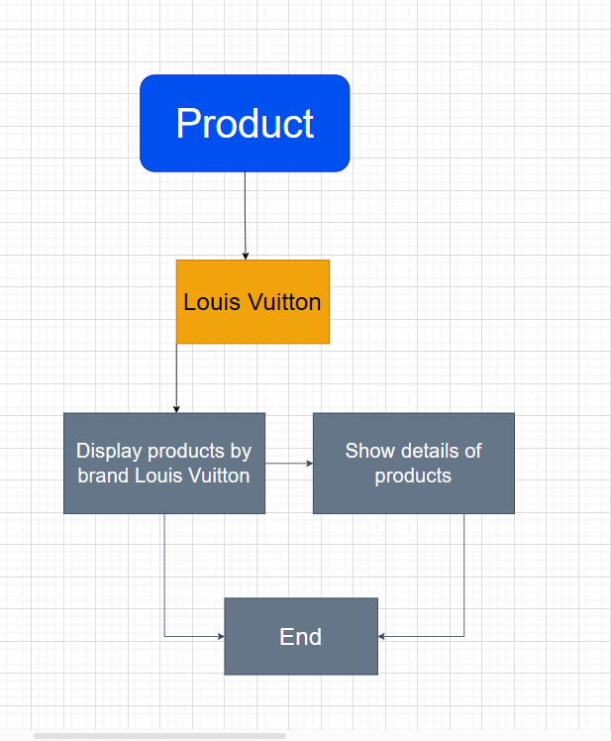

**5.Prada**

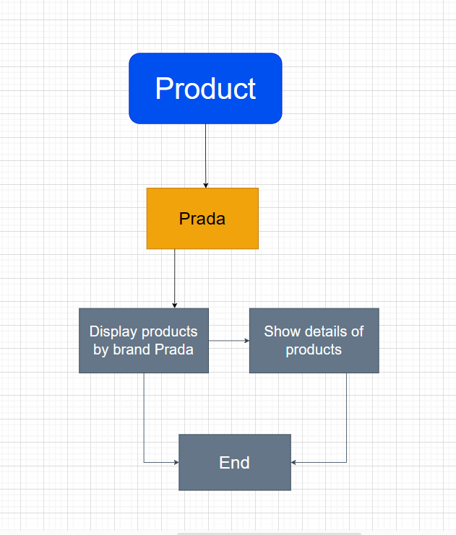

**6.Compare**

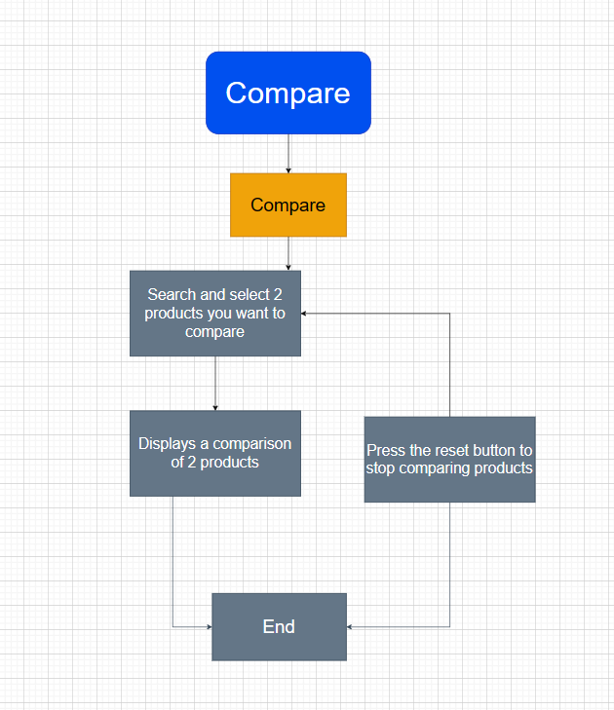

# **Main Screens**



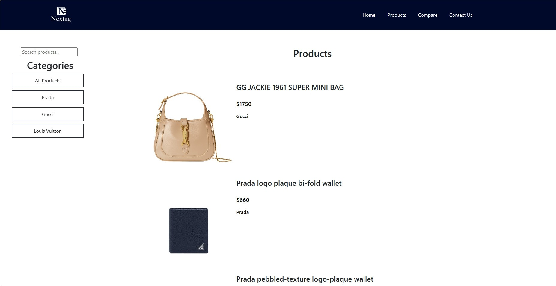

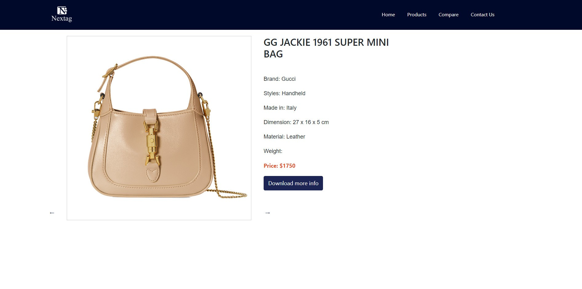

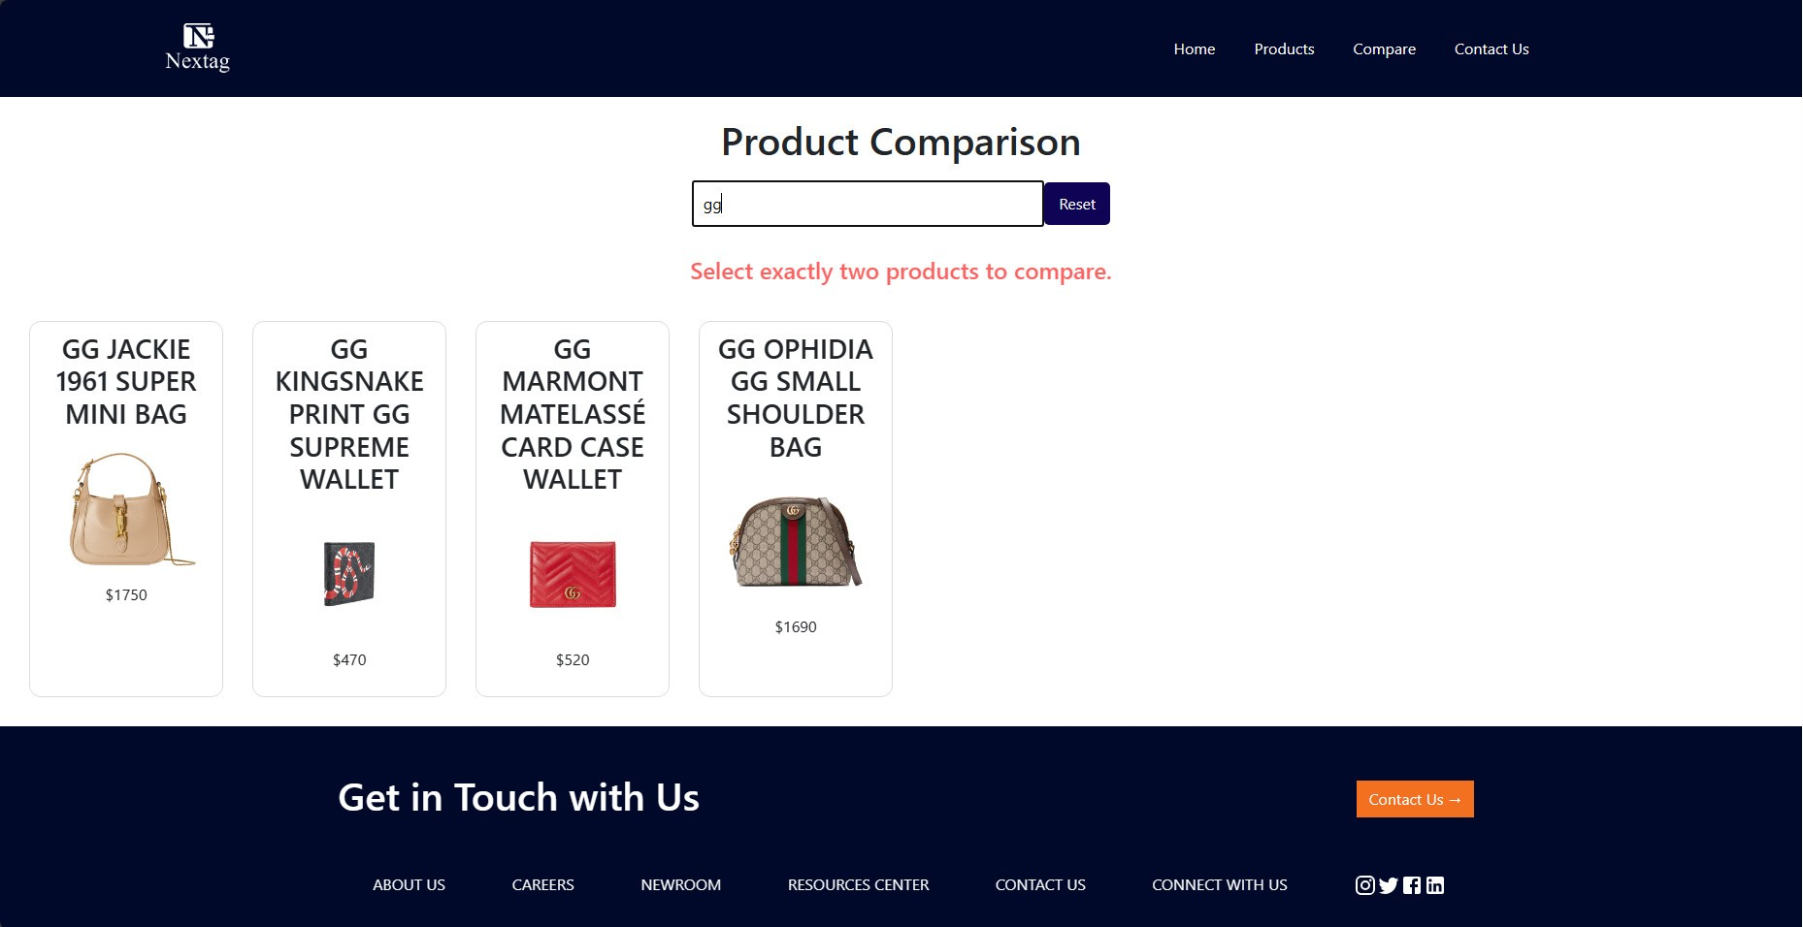

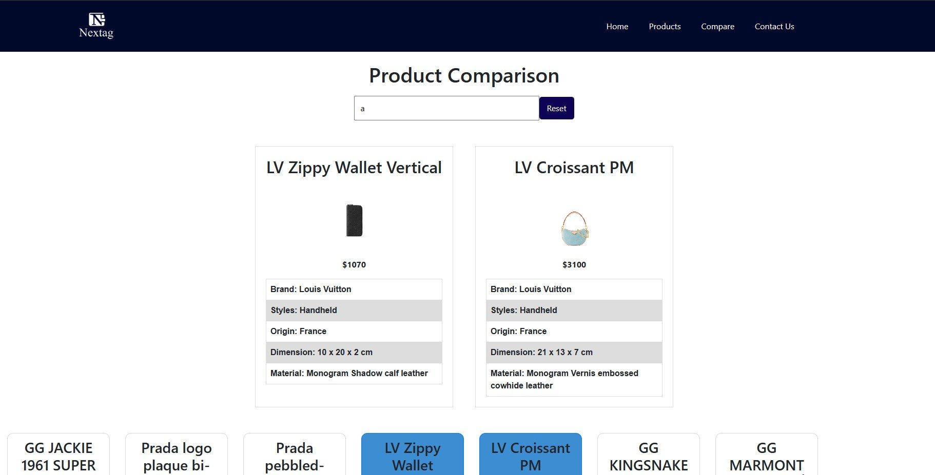

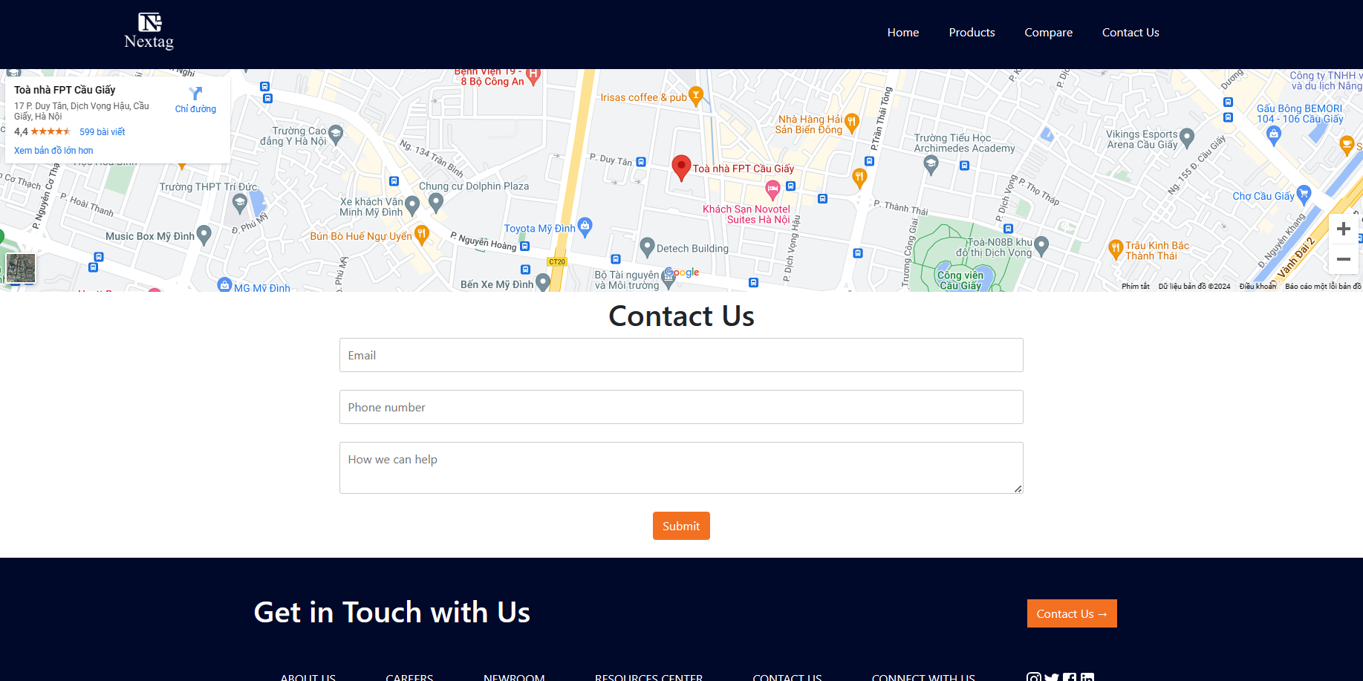

# **Hardware/ Software Requirements**

## **Hardware**

* A minimum computer system that will help you access all the tools in the

courses is a Pentium 166 or better

* 64 Megabytes of RAM or better

## **Software**

* ReactJS
* Chrome
* HTML
* JavaScript
* Css